PRESENTATION PROJECT OVERVIEW

It is critical for students to leave High School with the ability to conduct a strong, well thought-out and executed formal presentation for a live audience. Being able to do so requires an amalgam of different 21st Century Skills, including:
Communication
Critical Thinking
Creativity
Global Awareness
Technology

Lab meetings, conferences, workshops – there are a myriad of circumstances and venues that will require you to convey your knowledge or an idea to a group of people.

You will prepare and conduct 2 formal presentations this semester. Each presentation will be on a different topic, and no two students will choose the same topic.

This is your chance to research and present on topics of your choice that are relevant to astronomy and our course content. You will become our local expert on these topics and effectively teach the rest of the class what you’ve learned.

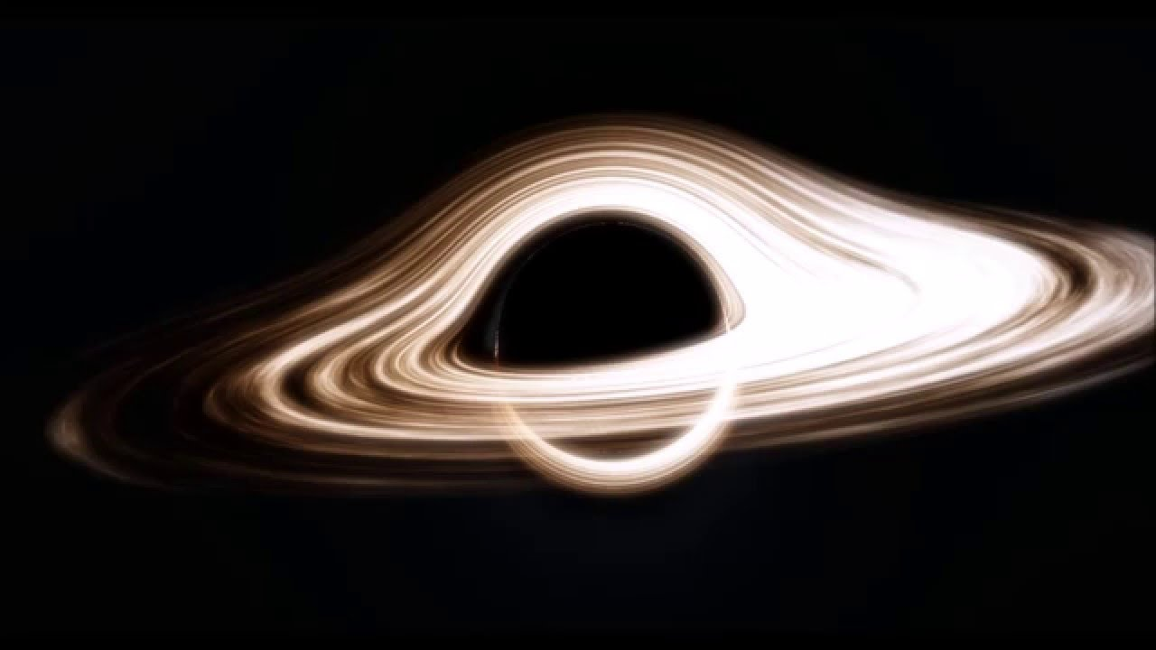
Presentation # 1: worth 40 points in total
- 5-7 minutes in length
- 5-10 slides in length

Due date: Tuesday, March 7th.

Presentation # 2: worth 100 points in total
- 7-10 minutes in length
- 7-12 slides in length

Due date: TBA

While I expect 100% effort on both presentations, the first presentation is worth less points because it is a shorter presentation and your first run-through with the process. Giving a good presentation is a learning process that takes practice.

We will be taking time to work on these presentations during class time in the Media Center on a (mostly) weekly basis. You can find that information here: http://proctorscience.weebly.com/astronomy.html

You are expected to become well-versed in your topic and deliver a presentation that has been rehearsed and refined. You will be teaching your fellow classmates about your topic, so your presentation should be clear and informative.

